# SECOND SEMESTER 2020-2021

Course Handout Part II

Date: 16-01-2021

In addition to part-I (General Handout for all courses appended to the time table) this portion gives further specific details regarding the courses.

*Course No.* :**MF F485**

*Course Title* :**SUSTAINABLE MANUFACTURING**

*Instructor-in-charge* : **Dr. Kundan Singh**

**Scope and Objective of the Course:** Sustainable manufacturing is related with the manufacturing of parts with minimal environment impact by reducing the energy requirement and conserving the natural resources. This course will give insight to uses of environmental friendly advanced material for sustainable manufacturing. Sustainable design concept for sustainable manufacturing will also be taught. Different manufacturing processes which uses the eco-friendly methods for producing the sustainable product will be introduced in the class.A multi- disciplinary approach will be undertaken. Collection and analysis of sustainable practices from various industries will also be discussed.

# Text Books

1. D. Dornfeld (ed.), Green Manufacturing: Fundamentals and Applications, Springer, New York, 2013 [1]
2. Anthony Johnson, Sustainability in Engineering Design, Elsevier publication, 2014 [2]
3. Gunther Seliger (ed.), Sustainability in Manufacturing, Springer, 2007 [3]

# Reference Books

1. Wen LI(ed), Efficiency of manufacturing process: Energy and Ecological perspective, Springer, Australia, 2015.
2. 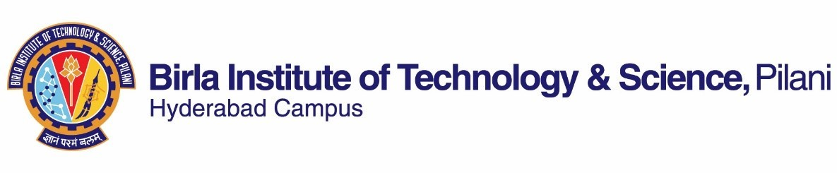David T Allen & David R Shonnard, Sustainable engineering, Pearson, India, 2015.
3. J Paulo Davim, Sustainable Manufacturing, Wiley, UK, 2010
4. Rob Thompson, Sustainable Materials, process and production, Thames & Hudson, 2013

# Course Plan:

|  |  |  |  |  |  |  |
| --- | --- | --- | --- | --- | --- | --- |
| **Lecture**  **No.** | **Learning**  **tives** | | **Objec-** | **Topic to be covered** | **Chapter in the**  **text book** | |
| 1-4 | Fundamentals  sustainability | | of | Sustainability importance,  Sustainability challenges, Triple bottom line of sustainability and draw- back,4Rs of sustainability, Sustainable engineering to Sustainable manufacturing, | Class notes and  [1]-1 | |
| 5-8 | Life  (LCA) | cycle | analysis | why LCA?, LCA methodology, LCA tools, Examples for LCA | [3]-3 | |
| 9-13 | Sustainable engineering design | | | Sustainable design for  sustainable manufacturing, Taguchi analogy, Close loop material cycle, Total design control, SED whole life model, Sustainable design constraint, Smart factories | Class notes and  [2]-3 | |
| 14-18 | Measurement of sustainability | | | Metrics used for sustainable  manufacturing, Sustainable Measurement Using Carbon Dioxide, Energy parameters, Sustainable Life Value Model | Class  and[2]-6 | notes |



|  |  |  |  |
| --- | --- | --- | --- |
| 19-26 | Manufacturing process assessment for sustainability | Assessment of micro and  macro manufacturing process, Energy requirement for micro-manufacturing process for various products | Class notes  and[1]-1 |
| 27-34 | Machine tool and cut-  ting tool sustainability analysis | Machine tool and cutting  tool reliability analysis methodologies, Bernstein distribution, Cutting tool wear role in sustainability | class notes and  [1]-2 |
| 35-38 | Manufacturing process condition analysis | Effect of workpiece condition, Role of lubrication and MQL in SM, Analysis of process stability for SM | [1]-3 |
| 39-42 | Case studies | Different case studies on  practice of sustainable manufacturing in industries | Class notes |

**Evaluation Scheme**

|  |  |  |  |  |
| --- | --- | --- | --- | --- |
| **Component** | **Duration** | **Weightage(**%**)** | **Date** & **Time** | **Nature of**  **Component** |
| Mid Sem. Test | 90 Min. | 30 | 03/03 3.30 - 5.00PM | Open Book |
| Quiz/home  assignment | – | 20 | – | Open Book |
| Project/case  study | – | 15 | – | Open Book |
| Comprehension  examination | 2 Hrs. | 35 | 08/05 FN | Open Book |

**Chamber Consultation Hour:** Will be decided based on Time table and avail- ability of the students.

**Notices:** All notices will be put up on CMS only.

**Make-up Policy:** Make-up will be given with prior concern and genuine reasons only.

**Academic Honesty and Integrity Policy:** Academic honesty and integrity are to be maintained by all the students throughout the semester and no type of academic dishonesty is acceptable.

# INSTRUCTOR-IN-CHARGE